DCC-GARCH correlation: USDCHF and EURGBP
Method 09 / GARCH(1,1) + Engle DCC / Alpari D1 full available history

Study setup
Logical pair: USDCHF , EURGBP
Broker symbols: USDCHF_i , EURGBP_i
Snapshot: 2026-11-03_majors_alpari_D1
Timeframe: D1
Matched return window: 1999-01-06 to 2026-11-02 (UTC bar dates)
Matched return count n: 7182
Dropped unfinished last bar dated 2026-11-03 UTC after a tick-volume check against the prior complete day.
USDCHF GARCH(1,1): mu=-0.000341, omega=0.003441, alpha=0.041011, beta=0.956758
EURGBP GARCH(1,1): mu=-0.000019, omega=0.000658, alpha=0.046457, beta=0.951873
DCC: a=0.046236, b=0.926142, a+b=0.972377
Burn-in ignored in path summaries and chart: first 60 updates
Complete matched rows (Excel): USDCHF-EURGBP_DCC_D1.xlsx
Complete matched rows (HTML table): USDCHF-EURGBP_DCC_D1_data.html

Method carried forward
DCC-GARCH first fits a constant-mean GARCH(1,1) on each matched daily log return of close, ln(close_t / close_t-1), then updates Engle (2002) dynamic conditional correlation on the standardised shocks z = residual / conditional sigma. Quotes are not inverted. Correlation targeting sets Q_bar to the sample correlation of z; a and b are estimated by maximising the bivariate Gaussian DCC likelihood with a >= 0, b >= 0, and a + b < 1. Path summaries ignore the first 60 updates. The headline is rho on the last day. Same-sample Pearson r on log returns is a side check only. A high |rho| does not prove cause, lead-lag, or a trading signal.

Results
Latest DCC rho: -0.061088
Post-burn-in path (n=7122): mean=-0.308574, median=-0.321783, min=-0.724757, max=0.469067, std=0.172066
Share of post-burn-in days with |rho| >= 0.4: 33.02%; |rho| >= 0.7: 0.06%
Same-sample Pearson r: -0.325886
Latest rho minus r: 0.264798

Conclusion
Over 7182 matched daily log-return rows for USDCHF and EURGBP (broker quote directions unchanged), latest DCC rho is -0.0611 (negative, weak conditional linear link in this sample) with fitted a=0.0462, b=0.9261 (a+b=0.9724). After a 60-day burn-in, path mean is -0.3086 and std is 0.1721. Same-sample Pearson r is -0.3259 (latest rho minus r = 0.2648). This does not establish cause, lead-lag, or a lasting trading rule.

Charts
Daily closes

Daily log returns
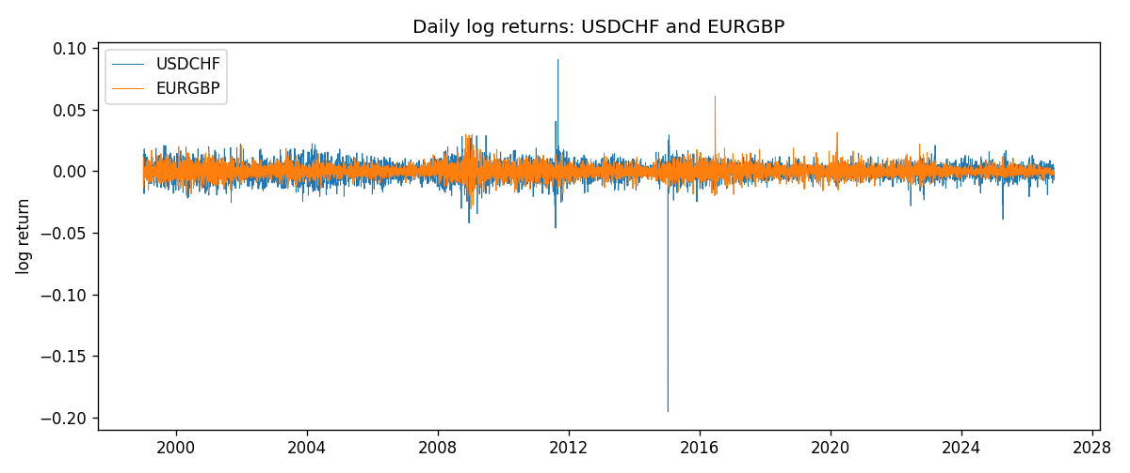
DCC rho path with Pearson r reference
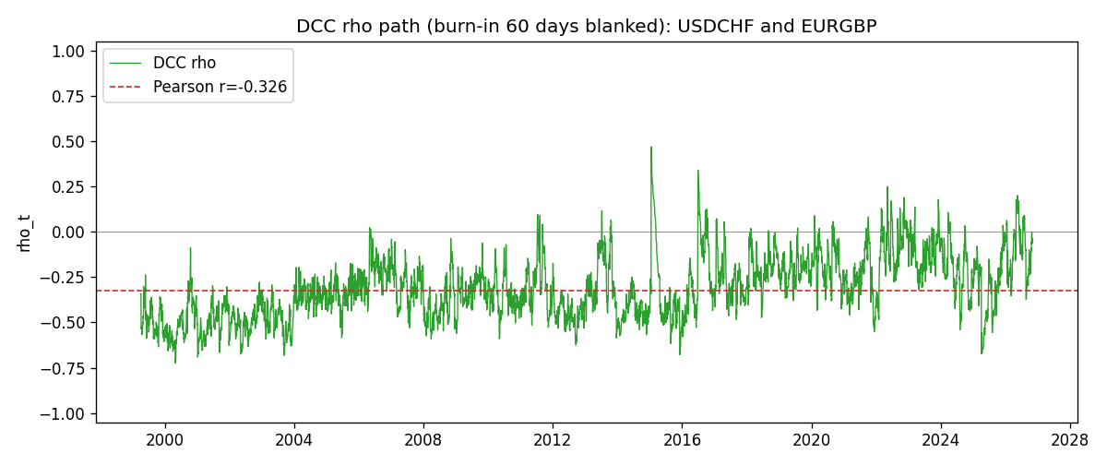

Data report
Every matched row that entered the DCC recursion is stored in the sibling Excel workbook named USDCHF-EURGBP_DCC_D1.xlsx. Embedding all rows as a Word table is impractical at this length; the Word file holds the column list, column summaries, and the first and last 15 matched rows.
Columns: time, USDCHF_open, EURGBP_open, USDCHF_high, EURGBP_high, USDCHF_low, EURGBP_low, USDCHF_close, EURGBP_close, USDCHF_tick_volume, EURGBP_tick_volume, USDCHF_spread, EURGBP_spread, USDCHF_real_volume, EURGBP_real_volume, USDCHF_log_return, EURGBP_log_return, USDCHF_sigma, EURGBP_sigma, USDCHF_z, EURGBP_z, q11, q22, q12, rho_t
Column summaries (matched calculation rows)
column | count | mean | std | min | 25% | 50% | 75% | max
USDCHF_open | 7182 | 1.0972493 | 0.25210985 | 0.72022 | 0.9204925 | 0.989875 | 1.237175 | 1.8219
EURGBP_open | 7182 | 0.7869939 | 0.09664695 | 0.5734 | 0.6877 | 0.833905 | 0.865225 | 0.9769
USDCHF_high | 7182 | 1.1025378 | 0.25385182 | 0.73305 | 0.924695 | 0.99351 | 1.242175 | 1.8313
EURGBP_high | 7182 | 0.79007306 | 0.09702085 | 0.5789 | 0.6897 | 0.836955 | 0.8681 | 0.9799
USDCHF_low | 7182 | 1.092133 | 0.25052689 | 0.08565 | 0.9171825 | 0.986205 | 1.2312 | 1.8121
EURGBP_low | 7182 | 0.7842938 | 0.09646529 | 0.5682 | 0.685725 | 0.83166 | 0.86287 | 0.9661
USDCHF_close | 7182 | 1.09724 | 0.25200902 | 0.72025 | 0.9207375 | 0.98991 | 1.23715 | 1.8217
EURGBP_close | 7182 | 0.78703952 | 0.09664503 | 0.5735 | 0.687825 | 0.83398 | 0.865375 | 0.977
USDCHF_tick_volume | 7182 | 74362.695 | 113509.88 | 18 | 12814.25 | 40258.5 | 70446 | 858589
EURGBP_tick_volume | 7182 | 87145.49 | 145506.26 | 154 | 6593.75 | 44371 | 81432 | 1424684
USDCHF_spread | 7182 | 26.020746 | 24.692144 | 0 | 5 | 16 | 50 | 100
EURGBP_spread | 7182 | 21.320663 | 19.117614 | 0 | 4 | 13 | 40 | 50
USDCHF_real_volume | 7182 | 2.3303821e+10 | 8.915094e+10 | 0 | 0 | 0 | 0 | 1.9331921e+12
EURGBP_real_volume | 7182 | 2.7876168e+10 | 1.3522356e+11 | 0 | 0 | 0 | 0 | 3.5726265e+12
USDCHF_log_return | 7182 | -7.199e-05 | 0.00659004 | -0.19545699 | -0.00335239 | 7.626e-05 | 0.00331734 | 0.09051364
EURGBP_log_return | 7182 | 2.529e-05 | 0.00487429 | -0.03067367 | -0.00262165 | -0.00010006 | 0.00256425 | 0.06075387
USDCHF_sigma | 7182 | 0.00654709 | 0.00255019 | 0.00361398 | 0.00507601 | 0.00609961 | 0.00729341 | 0.03990355
EURGBP_sigma | 7182 | 0.00463787 | 0.00169441 | 0.00185854 | 0.00343944 | 0.00442348 | 0.00552855 | 0.01547073
USDCHF_z | 7182 | 0.0393536 | 0.99904315 | -34.479539 | -0.48261344 | 0.06929381 | 0.59706596 | 6.7440511
EURGBP_z | 7182 | 0.00820558 | 1.0000734 | -3.7919663 | -0.62081539 | -0.02007425 | 0.59868396 | 8.4814176
q11 | 7182 | 1.0000397 | 1.713262 | 0.54944609 | 0.77045673 | 0.86715595 | 0.98638406 | 55.732798
q22 | 7182 | 1.0004442 | 0.23615318 | 0.60989731 | 0.84671714 | 0.95865207 | 1.1045108 | 4.504966
q12 | 7182 | -0.29130325 | 0.22951726 | -1.6292729 | -0.40611691 | -0.29213651 | -0.17419062 | 3.7390503
rho_t | 7182 | -0.30929805 | 0.17163287 | -0.7247566 | -0.43695801 | -0.32286609 | -0.19968277 | 0.46906683
First 15 matched rows (selected columns)
time | USDCHF_log_return | EURGBP_log_return | USDCHF_sigma | EURGBP_sigma | USDCHF_z | EURGBP_z | q11 | q22 | q12 | rho_t
1999-01-06 | 0.013605652 | -0.013303338 | 0.0085572363 | 0.0055998251 | 1.6297902 | -2.3722391 | 1 | 1 | -0.29129805 | -0.29129805
1999-01-07 | -0.0093883841 | 0.011051402 | 0.008853294 | 0.0061735694 | -1.0219401 | 1.7932277 | 1.0765762 | 1.2139562 | -0.45658831 | -0.3993934
1999-01-08 | 0.011040268 | -0.004943862 | 0.0088708881 | 0.006483694 | 1.2829737 | -0.75954358 | 1.0729715 | 1.3005965 | -0.51564202 | -0.43649866
1999-01-11 | 0.0052963193 | -0.0012752393 | 0.0089970048 | 0.0064193176 | 0.62656043 | -0.19566338 | 1.0974512 | 1.258833 | -0.53065948 | -0.45148077
1999-01-12 | -0.0098275602 | 0.0033970309 | 0.0088934333 | 0.0062740387 | -1.0667098 | 0.54450489 | 1.0621691 | 1.1952505 | -0.50518058 | -0.44835328
1999-01-13 | -0.018259701 | 0.00042381861 | 0.0089279347 | 0.0061706675 | -2.0070546 | 0.071796529 | 1.0639519 | 1.1483023 | -0.50277024 | -0.45486285
1999-01-14 | -0.0024256692 | -0.0019793588 | 0.0094748868 | 0.0060265703 | -0.22003654 | -0.32525048 | 1.1992424 | 1.0913516 | -0.48034548 | -0.41987292
1999-01-15 | 0.01794228 | -0.0076715819 | 0.0092959047 | 0.0059005024 | 1.9667938 | -1.2969011 | 1.1405296 | 1.0432601 | -0.44960549 | -0.41217535
1999-01-18 | -0.0031856384 | 0.00071280921 | 0.0098351498 | 0.0059938857 | -0.2892473 | 0.12212831 | 1.262767 | 1.0715955 | -0.54237978 | -0.46625815
1999-01-19 | -7.2518946e-05 | -0.0014261269 | 0.0096552245 | 0.0058556256 | 0.027791061 | -0.2402669 | 1.2009922 | 1.0207616 | -0.51200028 | -0.46242144
1999-01-20 | 0.0072259871 | 0.0019960086 | 0.0094625179 | 0.0057267745 | 0.79966401 | 0.35189487 | 1.1399473 | 0.97566162 | -0.48253999 | -0.4575529
1999-01-21 | -0.0038232689 | -0.00071240297 | 0.0093999821 | 0.005609998 | -0.37047102 | -0.12356316 | 1.1129414 | 0.93694893 | -0.44193626 | -0.43277836
1999-01-22 | -0.0001445609 | -0.0017118406 | 0.0092401441 | 0.0054813846 | 0.021242848 | -0.30879547 | 1.0647099 | 0.89607606 | -0.41522554 | -0.42510477
1999-01-25 | 0.0024546976 | -0.0054402425 | 0.009057258 | 0.005366424 | 0.30865252 | -1.0101752 | 1.0137158 | 0.86192484 | -0.39290743 | -0.42033682
1999-01-26 | 0.0020889617 | -0.00057438255 | 0.0088966965 | 0.0053706261 | 0.27311368 | -0.10337131 | 0.97087182 | 0.87306852 | -0.38635035 | -0.41963934
Last 15 matched rows (selected columns)
time | USDCHF_log_return | EURGBP_log_return | USDCHF_sigma | EURGBP_sigma | USDCHF_z | EURGBP_z | q11 | q22 | q12 | rho_t
2026-10-13 | -0.0024955621 | 0.00020130374 | 0.004775354 | 0.0020167084 | -0.4512156 | 0.10934532 | 0.71275232 | 0.81866389 | -0.17288962 | -0.22633243
2026-10-14 | 0.0029388325 | 0.0011241873 | 0.0047278311 | 0.001984809 | 0.6936966 | 0.57607618 | 0.69714564 | 0.78637422 | -0.17044789 | -0.23020526
2026-10-15 | -0.0097855323 | -0.00087557391 | 0.0047086112 | 0.0019688682 | -2.0058323 | -0.4349504 | 0.69552756 | 0.77126053 | -0.14742853 | -0.20129075
2026-10-16 | -0.0036230826 | -0.0020380844 | 0.0050214193 | 0.0019467365 | -0.65364681 | -1.0370538 | 0.85780245 | 0.75066612 | -0.10424842 | -0.12991295
2026-10-19 | 0.0036351779 | -0.00056950988 | 0.0049910122 | 0.0019653443 | 0.79663716 | -0.27999979 | 0.84182363 | 0.77257136 | -0.073253607 | -0.09083415
2026-10-20 | -0.0026281224 | -0.0035906254 | 0.0049825134 | 0.0019381913 | -0.45906038 | -1.8426518 | 0.83661317 | 0.74675806 | -0.08620286 | -0.10906097
2026-10-21 | -0.00040027413 | -0.00140647 | 0.004930574 | 0.0020577145 | -0.012052604 | -0.67417325 | 0.81218852 | 0.87621328 | -0.048772279 | -0.057814891
2026-10-22 | -0.0048036381 | -0.0018743924 | 0.0048583468 | 0.002045886 | -0.91858207 | -0.90678488 | 0.77983102 | 0.86013485 | -0.05284075 | -0.064518676
2026-10-23 | 0.005652514 | 0.00082421033 | 0.0048727544 | 0.0020518118 | 1.2299741 | 0.41106314 | 0.78886997 | 0.86224706 | -0.018472158 | -0.022397475
2026-10-26 | 0.0018407959 | 0.00013133309 | 0.0049532024 | 0.0020263765 | 0.44045118 | 0.07429369 | 0.82817496 | 0.83399817 | -0.0017776313 | -0.0021389375
2026-10-27 | 0.0026100526 | -0.0019957343 | 0.004900262 | 0.0019938576 | 0.60219239 | -0.9913047 | 0.8035996 | 0.80027833 | -0.0081797737 | -0.010200017
2026-10-28 | -0.0010142111 | 0.00066967224 | 0.0048657373 | 0.0020078511 | -0.13838874 | 0.34309623 | 0.78863643 | 0.81422884 | -0.043222667 | -0.053938629
2026-10-29 | -0.0048680164 | -0.0011722209 | 0.004797321 | 0.001981243 | -0.9436868 | -0.58196144 | 0.7588972 | 0.78715656 | -0.05027201 | -0.065043547
2026-10-30 | 0.00071594559 | -0.0024205543 | 0.0048170225 | 0.0019657071 | 0.21938728 | -1.2216166 | 0.77164388 | 0.77230019 | -0.029213287 | -0.03784242
2026-11-02 | -0.0071459744 | 0.00089940465 | 0.0047529148 | 0.0020029399 | -1.4317796 | 0.4586351 | 0.74449957 | 0.81188167 | -0.047493519 | -0.061087978

